Document History
Basic information
Document owner |  | James Buller, Senior Windows Engineer
Approver |  | Dan Morgan, Windows Team Lead
Administrator |  | James Buller, Senior Windows Engineer
Status |  | Live
Archive until |  | N/A
Review cycle |  | Annually
Document location |  | ISSC1 Infrastructure Team SharePoint
Document classification: |  | Internal
Special instructions |  | N/A
Responsible function |  | ISSC1 Infrastructure Team
Addressee(s) within Arvato |  | ISSC1 Infrastructure Team
Training approach |  | Team and 1:1
Version information
Version: | Date: | Author: | Comments:
0.1 | 20/02/2023 | James Buller | Draft
1.0 | 22/02/2023 | James Buller | Initial / Distrubuted / Trained
1.1 | 20/07/2023 | James Buller | Updates (Bold)
1.2 | 11/12/2024 | James Buller | Updates
1.3 | 21/03/2024 | Kevin Feathers | Added Civica boot order in Evening Patching section

Contents
Scope: 3
Prerequisites: 3
Information: 3
Patch Tuesday. 3
Non-Production and Hosted Services Domain Patching. 3
Production and SSC (Swansea) Domain Patching. 3
Patching Procedure. 4
Day before the patching session – Reports. 4
Day of the patching session – Patch Approval. 4
Day of the patching session – Patch Deployment. 5
Evening of the patching session – Patch Deployment. 8
Trouble Shooting. 9
Completion of patching. 11
Information. 11
Filter’s setup. 11
Patch Approval. 11
Patch Deployment (System). 11

Scope:
This document will assist in the monthly patching activities for all domains each month, detailing the required steps needed for successful patching deployments. If in doubt, then please seek advice before proceeding.
  - Activities are to be carried out by ICT infrastructure team members only.

Prerequisites:
Here are the following that are required to successfully perform patching activities.
- Access and login details to the patch manager server in hosted services (AWSARVM312)
- Access and login details for the following systems
  - AWSARVM312 in hosted services.
  - AWS Console.
  - Domain Administrator level access to all environments.

Information:

Patch Tuesday.
Patching sessions are carried out in two sessions after ‘Patch Tuesday’. Patch Tuesday is the commonly known name of Microsoft's monthly release of security fixes for the Windows operating system (OS) and other Microsoft software. It is also referred to as Update Tuesday.
Microsoft releases most of its security patches on Patch Tuesdays. Fixes for more serious vulnerabilities, called out-of-band patches, are the exception.
Patch Tuesday occurs on the second Tuesday of each month.

Non-Production and Hosted Services Domain Patching.
This patching window will normally take place on the 2 days after Microsoft releases updates from ‘Patch Tuesday’ to allow us to fully check patches and any issues before rolling out to other domains. This will be approved in normal business hours by a member of the team and deployed via a deployment window out of hours which will be checked periodically on the console or emailed reports.
Domains Patched:
- SSAHS
- SSANP

Production and SSC (Swansea) Domain Patching.
This patching window will normally take place on the 4 days after Microsoft releases updates from ‘Patch Tuesday’ and will be approved in normal business hours by a member of the team and deployed via a deployment window out of hours which will be checked periodically on the console or emailed reports.
Domains Patched:
- SSC
- SSAP

Patching Procedure.

Day before the patching session – Reports.
The day before the patching session an email will be sent to the windows support email box that will have a report attached to it advising what patches are available and to be approved / downloaded in readiness for patching session as shown below.
Patches shown on this report will also include third party software updates that are currently supported by the venders such as Adobe, Putty and WinSCP

Day of the patching session – Patch Approval.
Below are the steps covering the in hours activities to be carried out by the assigned engineer.
- Access the patch manager console.
  - ARVSSAADM01 > Edge > https://awsarvm312:8383/client#/login or
  - AWSARVM320 > AWSARVM312 > Edge > https://awsarvm312:8383/client#/login
- Once logged in you will see how many patches are awaiting approval on the home page.
- From the navigation pane above select ‘Patches’.

- Using the filter on this page firstly select ‘Awaiting Approval’ – These are updates that are classed as Critical, Important, Low and Moderate and have not been approved or downloaded.
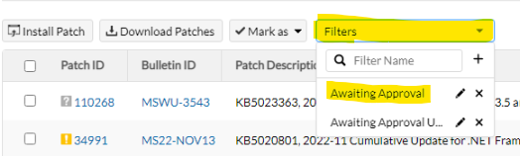
- You will see a page with all the patches that are in the status of ‘Not Approved’ and ‘Yet to be downloaded’.

- These patches need to be review in accordance with the team and a brief that might come from the security team regarding potential issues, once reviewed the tick box can be added and then ‘Mark as’ approved in the first instance and then tick all the relevant patches again and then ‘Download Patches’.
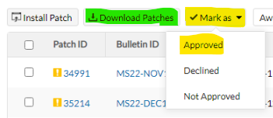
- The number of missing patches awaiting approval on the home page should now have decreased depending on the number of patches approved and downloaded.

Day of the patching session – Patch Deployment.
Below are the steps to select the systems that need patching and to set up the window of deployment.
Domain controllers can now be patched within normal working hours with either a ‘controlled’ reboot or a reboot outside of normal working hours. This will be built in to the
- Access the patch manager console.
  - ARVSSAADM01 > Edge > https://awsarvm312:8383/client#/login or
  - AWSARVM320 > AWSARVM312 > Edge > https://awsarvm312:8383/client#/login
- From the home screen navigation pane above select ‘Systems’.
- Now using the filter drop down select the relevant option for assigned patching session.
  - ‘Hosted Services’ for all systems in the Hosted Services ‘SSAHS’ domain.
  - ‘SSANP BAU’ for all systems in Non Production ‘SSANP’ that are not used by FOSS and are not domain controllers.
  - ‘SSANP FOSS’ for all systems in Non Production ‘SSANP’ that are used by FOSS.
  - ‘SSANP DCs’ for all domain controllers that are on the ‘SSANP’ domain.
  - ‘SSAP BAU’ for all systems in Production ‘SSAP’ that are not used by FOSS and are not domain controllers.
  - ‘SSAP FOSS’ for all systems in Production ‘SSAP’ that are used by FOSS.
  - ‘SSAP DC’s’ for all domain controllers that are on the ‘SSAP’ domain.
  - ‘SSC’ for all systems that relate to SSC and are not domain controllers.
  - ‘SSC DCs’ for all domain controllers that are on the ‘SSC’ domain.

- You will then need to sort the machines by the number of patches needed in descending order.
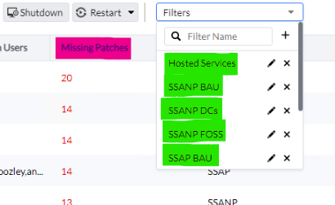
- Select all the machines on the list making sure that all the machines are on this page.
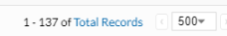
- Once all the machines are selected you will need to then click on the above buttons marked ‘Deploy Approved Patch’.
- On the next screen the following needs to be completed –
  - Name
    - SSAHS *DATE*
    - SSAP FOSS *DATE*
    - SSAP BAU *DATE*
    - SSAP DCs *DATE*
    - SSANP FOSS *DATE*
    - SSANP BAU *DATE*
    - SSANP DCs *DATE*
    - SSC *DATE*
    - SSC DCs *DATE*
  - A description can be added if needed or requested.
  - Apply the relevant deployment policy from the filter.
    - SSAHS Policy.
    - SSC Policy.
    - SSANP Policy.
    - SSAP Policy.
    - DC Patching tasks then use ‘Download – Install – No Reboot’.
  - Tick ‘Enable Notification’ and add the Windows Support email address.
- Leave all other options if not specified above / below and press Deploy.
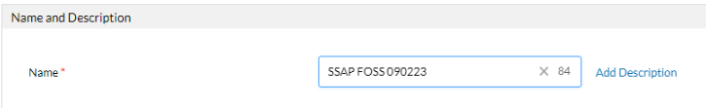
Use the options below to help with troubleshooting if needed (SSP).
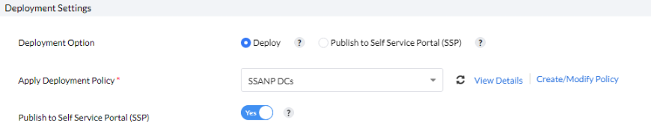
Add time and date to match the patch window +30 minutes after the end of the window.
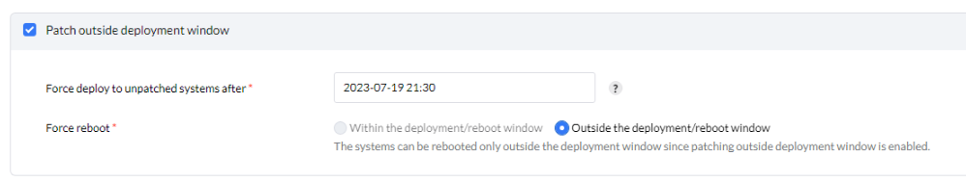
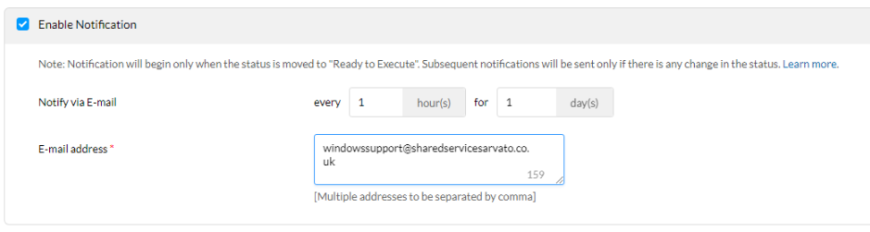
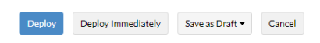
- This will now enter a state of ‘Ready to Execute’ on the next window and will be installed during the window of 6pm and pm that evening.

Evening of the patching session – Patch Deployment.
Below are the steps to check and monitor the progress of the patch installation session.
For the best progress check then log in any time after 9.30pm.
- Access the patch manager console.
  - ARVSSAADM01 > Edge > https://awsarvm312:8383/client#/login or
  - AWSARVM320 > AWSARVM312 > Edge > https://awsarvm312:8383/client#/login
- From the home screen select the ‘Deployment’ option.
- The deployment task that was created should provide a status of ‘In Progress’, if it is showing any other status then refer to the troubleshooting section.
- By selecting the deployment task, you will see the summary page of the progress of the deployment. Example below.
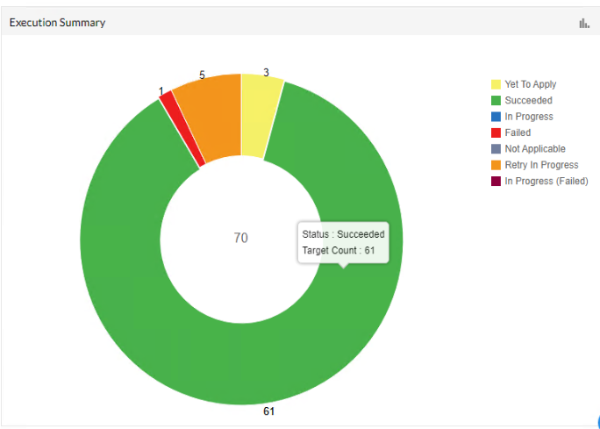
- From this screen you will be able to see the status in real time list of each machine by clicking on ‘Execution Status’ on the menu bar. These machines will be in various states as shown below. ‘Remarks’ provide more detailed information if needed.
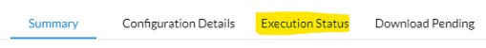
Succeeded – Patch installed correctly.
Yet to Apply – Install has not yet started.
Retry in Progress – Pending Reboot / Install Pending another activity
Failed – Patch install failed
- Once all machines have been patched successfully, they will show on the systems tab as ‘Healthy’. If they show any other status, then they will need to be scanned again and missing patches will need to be installed as above either by using the SSP portal on the machine or navigating to the patch directory and installing manually.
C:\Program Files (x86)\ManageEngine\UEMS_Agent\patches\
- Civica Services:
The Civica Servers need to be started in the following order:
482(DB), 481(ReportDB), 483(Image), 484(App)
682(DB), 681(ReportDB), 683(Image), 684(App)

Once these boxes are up and running:
Restart the Drupal\Web Proxy instances.

Trouble Shooting.
- If any of the machines are in a status other than succeeded or Yet to Apply then select the machine for more details. This will tell you if the machine needs to be rebooted to finalise or why the patch hasn’t installed.
- When a machine has failed its updates then please see below for potential work arounds.
  - Connect directly to the machine as it might need a reboot in the first instance.
  - In some FOSS instances the machine might be off and will need to be turned on in the AWS console. If this is the case, then when the machine checks in with patch server it will install the updates.
  - If the machine has been rebooted a ‘Patch Scan’ will need to carry out to see if the patches are still needed to do this click on ‘Systems’ > find the specific machine and select the drop down to run a ‘Patch Scan’ > refresh the page until the scan is completed.
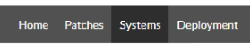
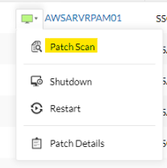

- Offline Machine (Turn on in AWS or VMware)
- Online Machine (All ok)
  - Log on to the machine directly and in the notification area you will find the icon for ‘Patch Manager’

Right click on this icon and select ‘Self Service Portal’, here you will be able to download and install updates manually from the patch manager service directly.
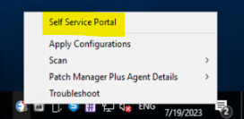
Alternatively if the patches have already been downloaded to the instance then navigate to the directory on the machine below and install the missing updates one by one according to the dashboard showing the updates that are missing.
C:\Program Files (x86)\ManageEngine\UEMS_Agent\patches\
Re-Scan the machine to verify all updates have been installed.
  - Once the scan is complete and patches are still needed then please select the machine and click ‘Deploy Approved Updates’ and follow the initial steps when creating the deployment only this time we are only focusing on the machine(s). You will need to select the profile when deploying these updates as ‘Download – Install – Reboot’ and at the bottom ‘Deploy Immediately’
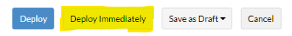

Completion of patching.
Once patching has been completed then please carry out application testing to make sure that all services are working as they should, then reply to the communication email sent from the change team to advise that the patching has been completed.

Information.

Filter’s setup.
When you first use the filters in the patch manage system, they will need to set up on first use or changed depending on updates to this document. These are shown below.

Patch Approval.
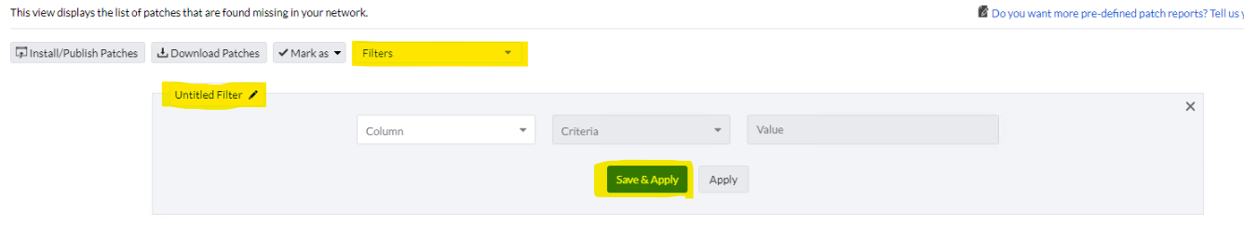
Name – ‘Awaiting Approval’
Settings – Severity EQUAL Critical, Important, Low, Moderate, Unrated ‘add +’ Approve Status EQUAL Approved, Not Approved ‘add +’ Download Status EQUAL Yet to be downloaded.
Save & Apply

Patch Deployment (System).
Name – ‘Hosted Services’
Settings – Domain Name EQUAL SSAHS
Name – ‘SSANP BAU’
Settings – Domain Name EQUAL SSANP ‘add +’ Computer Name LIKE AWSARVM ‘add +’ Custom Group NOT EQUAL SSANP DCs
Name – ‘SSANP FOSS’
Settings – Domain Name EQUAL SSANP ‘add +’ Computer Name LIKE AWSARF
Name – ‘SSANP DCs’
Settings – Domain Name EQUAL SSC ‘add +’ Custom Group EQUAL SSANP DCs

Name – ‘SSAP BAU’
Settings – Domain Name EQUAL SSAP ‘add +’ Computer Name LIKE AWSARVM ‘add +’ Custom Group NOT EQUAL SSAP DCs
Name – ‘SSAP FOSS’
Settings – Domain Name EQUAL SSAP ‘add +’ Computer Name LIKE AWSARF
Name – ‘SSAP DCs’
Settings – Domain Name EQUAL SSC ‘add +’ Custom Group EQUAL SSAP DCs
Name – ‘SSC’
Settings – Domain Name EQUAL SSC ‘add +’ Custom Group NOT EQUAL SSC DCs
Name – ‘SSC DCs’
Settings – Domain Name EQUAL SSC ‘add +’ Custom Group EQUAL SSC DCs

Please make sure that there are no system awaiting reboots or systems with deployment failures, this information can be found in the home screen.

If any further assistance is needed, then please contact your line manager to seek further advice and guidance on any issues at all.

